Directions to upgrade JEP-100 control panel software
The following 3 step process allows the JEP100 control panels to be upgraded via the Ethernet using the standard NetConfig software application loading tool available to other Ethernet control panels and other Grass Valley products.

These instructions assume the control panel already has Jupiter JEP100 software loaded.

**************************************************************************************
* WARNING *
* The update process will change control panel’s network settings as well as the panel’s name. *
* For this reason it is strongly advised to only update one control panel at a time. *
* Please note down the current control panel’s settings before proceeding with these steps. *
* *
**************************************************************************************

Step 1) UDPDownload “DLM-III-D.bin”
Using the existing JEP100 software installation application “UDPDownload.exe” install the interim “DLM-III-D.bin” binary. These steps are described in the existing JEP100_Manual.pdf document. A brief description is also provided here.

*NOTE: The UDPDownload tool has limitations for the number of control panels on the system. It may be necessary to temporarily remove JEP100’s from the network so that only 3-4 JEP100 control panels are detected by the UDPDownload tool.

With Encore V1.7.4 installed on the PC, launch the UDP Download application by navigating to the default installation directory path, or equivalent installation path chosen: C:\Program Files\Grass Valley Group\Fusion\JEP100\UDPDownload.exe
In this same directory path you will find the following files, a brief description is provided below for what each file is used for.
- DLM-III-D.bin – Panel application used in step 1 containing an interim bootloader necessary for the second step for using the Update Manager application.
- JEP100.bin – Panel application used in step 2 containing the necessary application to allow the JEP100 to work with NetConfig.
- JEP100Backup.bin – Panel application used in step 2 that is a secondary file application in the event of the primary panel application getting corrupted or failing for any reason.
- JEP100.blz – Panel application file formatted to be used by NetConfig when downloading software application updates to the JEP100 control panels.
- PDL-RCM3200.bin – Boot loader application used to load the interim “DLM-III-D.bin” file to the control panel.
- UDPDownload.exe – Software application used for updating existing V1.2.0 Jupiter software to JEP100 control panels.
- UpdateMGR.exe – Software application used for updating a JEP100 control panel loaded with JEP100temp.bin application to work with NetConfig.
- JEP100_Manual.pdf – Existing JEP100 control panel manual used with Jupiter.
- Readme.doc – This document describing how to upgrade JEP100 control panels to work with both Encore and Jupiter as well as provides a NetConfig software update capability.

With the application UDPDownload running, the following screen should be displayed on the PC.
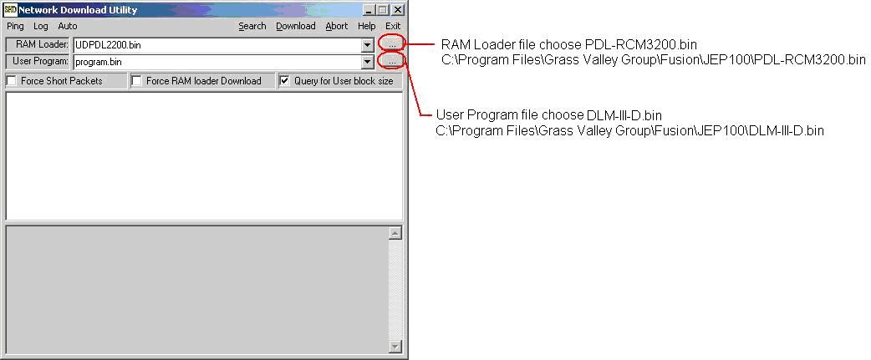
From the screen shot above select the “RAM Loader” file location as C:\Program Files\Grass Valley Group\Fusion\JEP100\PDL-RCM3200.bin (default installation path).
From the screen shot above select the “User Program” file location as C:\Program Files\Grass Valley Group\Fusion\JEP100\DLM-III-D.bin (default installation path).
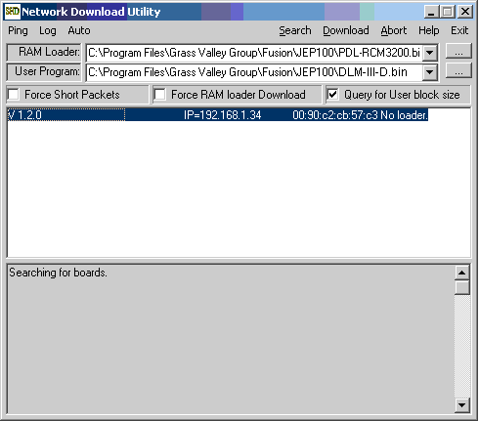
The tool will discover the JEP100 control panels available on the network (same subnet only).
Select the panel to download the interim application to, then select the “Download” option. The existing JEP100 application version under Jupiter control was probably V1.2.0 as shown above.

The control panel will no longer be accessible from the UDPDownload.exe application.

Step 2) Update Manager
With Encore V1.7.4 installed on the PC, launch the Update Manager application by navigating to the default installation directory path, or equivalent installation path chosen: C:\Program Files\Grass Valley Group\Fusion\JEP100\UpdateMGR.exe
With the application Update Manager running, the following screen should be displayed on the PC.
Control Panels are only able to be upgraded one at a time using this tool.
**************************************************************************************
* NOTE *
* During the previous step the control panel’s IP address has now been altered, it will be required *
* to reset the control panel’s IP address before proceeding. *
* *
**************************************************************************************
Select the panel from the discovery list (highlight) and then select the ‘Change IP’ option. Set the panel’s IP address to its original IP address, gateway, etc…
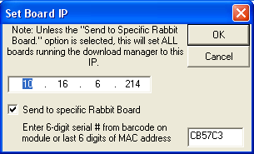

Next double click the first control panel to upgrade.
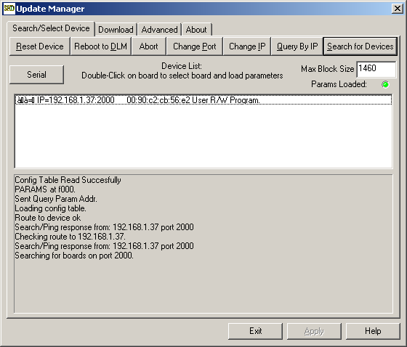
Then select the “Download” tab.

In the following steps the order of the files is very important. The backup file JEP100backup.bin must be added as the first file in the list.

Select “Add File” and navigate to C:\Program Files\Grass Valley Group\Fusion\JEP100\... then add the JEP100backup.bin file. This file is used as a secondary application in the event that the primary application should ever fail, and allows the user a means to reload software via NetConfig again in such an event.

Next select “Add File” again and navigate to C:\Program Files\Grass Valley Group\Fusion\JEP100\... to add the JEP100.bin primary file. This file is the application which will work with NetConfig.

Set the Primary and Backup files by highlighting the first added file “JEP100backup.bin” and then selecting “Set Backup”, then highlight the second added file “JEP100.bin” and selecting “Set Primary”. The tool screen should look like the following.
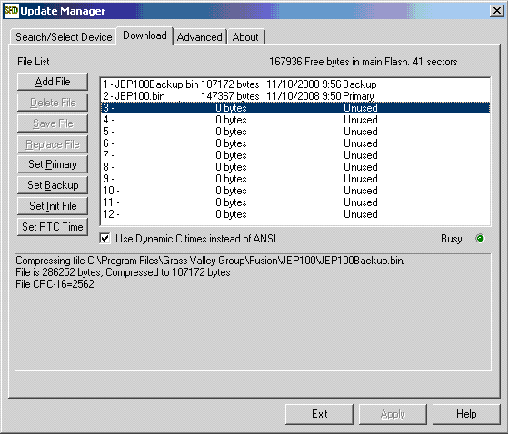
Next go back to the ‘Search/Select Device’ tab and select the “Reset Device”.
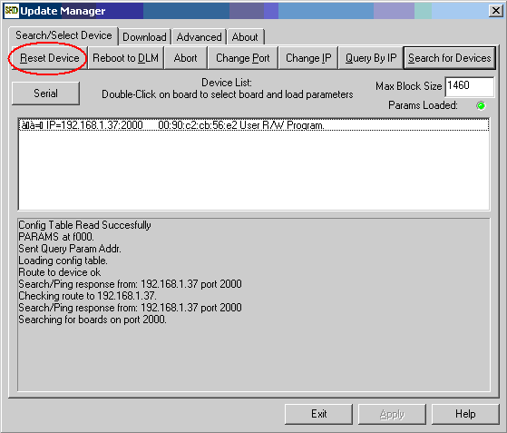
**************************************************************************************
* NOTE *
* During the second step the control panel’s name and network settings has now been altered, it *
* will be necessary to use NetConfig to reset the control panel’s name and network settings before *
* proceeding. *
* *
**************************************************************************************
Step 3) Reset Network and Panel settings via NetConfig
The software upgrade steps are complete, but you will once again have to set the control panel’s name and network settings appropriately via NetConfig.

The upgrade is now complete and the panel should now be visible in NetConfig as well as be able to perform software updates via NetConfig. Repeat the above steps for the other JEP100 control panels being upgraded ensure step 1 has been followed before performing this step.

